SHOPPING LIST FOR 20 SSH-STYLE MEALS
(Rev. Sept. 2022)
Drinks not needed! Cash donations to SSH are being used to deliver cases of bottled water to Samaritan House, to go with PTBE meals.
ITEM | YOU’LL NEED | PLUS EITHER:
SANDWICHES  If you have extra, place in separate labeled bag. | Two loaves of a standard 22- or 23-slice white/wheat. (This is one Costco double-pack.) | About 24 oz. smooth peanut butter  and 32 oz. jelly | OR:  Medium jar of mayo/ mustard and 60-80 slices cheese (Or less, if you add other items!)
CONTAINERS | 20 paper  lunch bags  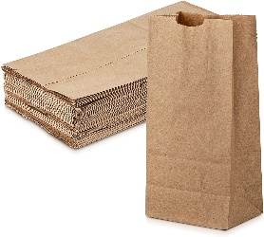 | 40 baggies  (20 sandwich-size +  20 snack-size for carrots)  Cookies can go directly in lunch bag. | OR:  40 pre-cut 10”x12” foil sheets  (20 for sandwiches + 20 to cut in half for carrots & cookies)
FRUIT | EITHER >> | 20 small apples  (1 per meal), or  20-40 mandarin oranges  (1-2 per meal) | OR: 20 small boxes of raisins  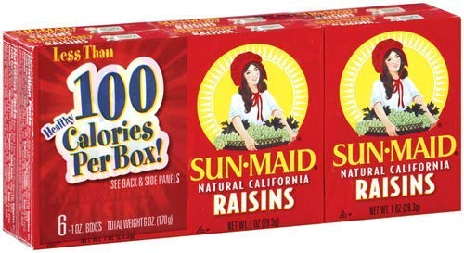
VEGETABLE | EITHER >>  (or other healthy snack) | 2 lbs. baby carrots  (About 4-5 carrots  per meal) | OR: 2 lb. bag sweet mini peppers  (2-3 per meal)
COOKIES | 2 regular packs Oreo-type cookies  (3 per meal) | You can substitute any small dessert.  Costco / Smart & Final have many. Note, a Costco box of Oreos covers about 43 meals.
NAPKINS | 20-40  (1-2 per meal, depending on quality) | Feel free to decorate bags or  include short notes of kindness!

